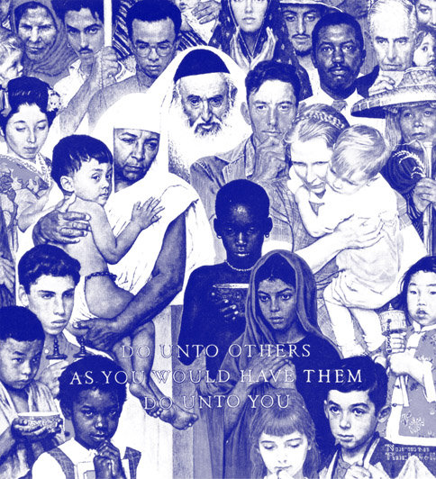 | 
PO Box 67-0235, Flushing, NY 11367-0235
Tel:+1-718-380-8499 • Fax: +1-877-738-0140 • adhiratha@aol.com

Dear Ambassador,

I am writing regarding the World Thanksgiving Day initiative. We want to continue the spirit of the UN dedication of year 2000 as the International Year of Thanksgiving. Our hope is that a draft resolution would now:
- Encourage annual days of thanksgiving in countries fostering the spirit of gratitude for life and the human experience;.
- Make clear that the day selected by individual countries may vary to reflect the various historical and cultural circumstances;
- Provide a day to build bridges across communities, honour local diversity or introduce truces among warring parties; and
- Present a periodic reminder to appreciate and celebrate the cornerstone of all religions - gratitude and recognition of a higher force which inspires and guides life.

We believe such a initiative to further the world’s historical healing experience of shared harvest thanksgivings and gratitude observances could have wide support from many delegations and might be submitted for consideration by the General Assembly in the next session. In order to assist we can provide initial background information:
- Some highlights and history of the previous initiatives in the UN community related to Gratitude and Thanksgiving observances
- The “Year 2000: International Year of Thanksgiving” resolution with statements by GA President and the Secretary - General
- An outline for the “World Thanksgiving Day”: draft resolution for consideration.

I can also include some summarized responses to related Questions which might assist the mission to review the context of proposal in discussions with colleagues .For example I provide background on:
- the Thanksgiving Square foundation and Center for World Thanksgiving which were instrumental in previous efforts, and .
- Some various ways the World Day of Thanksgiving could be implemented in the years ahead

We would like very much if your delegation would be able to join with others in sponsoring the draft resolution. I am available to discus this further at your convenience and to provide any additional information you might need.

Sincerely

Adhiratha Kevin Keefe
Liaison for World Thanksgiving Day

Draft
Encouraging the annual observance of a day of Thanksgiving or gratitude around the world.

